Objective 3: Youth Employment Ecosystem Mapping
The youth employment ecosystem across the three upazilas comprises a layered set of actors spanning government training and social protection offices, NGO and development partners, private employers, and the SCI implementing partner, with significant variation in depth and inclusivity across upazilas. In Satkhira Sadar, the ecosystem is the most developed: TTC Satkhira operates a government TVET centre with a dedicated job placement cell, employer links to RFL and Walton, and job fairs; DYD provides vocational training, microcredit, and employer referral; DWA offers multi-trade training alongside GBV referral and legal support; BSCIC provides 5% interest loans and plot allocation with a 30% women's priority quota; and Rishilpi International Foundation delivers home-based production linkage with raw material delivery and product collection, making it among the most inclusive actors for women with mobility and disability constraints.
In Debhata, Uttaran Shimanta Technical Institute stands out as the benchmark actor across all three upazilas, combining free residential training, transport allowance, job counselling, job fairs, six-month follow-up, and job replacement support; Taskia Garments offers women-only tailoring and block-batik apprenticeships with seasonal employer demand; and Noabeki Gonomukhi Foundation provides free training, loan support, and livelihood linkage, though its reported placement figures require independent verification.
In Ashashuni, where the ecosystem is most constrained, the most relevant NOW-tier actors are local tailoring shops and Tohomina Ladies Garments, which offer women-only apprenticeships aligned sector preference, SUS through its guru-shishya apprenticeship model with loan support, and local poultry and livestock providers with 80 percent female participation.
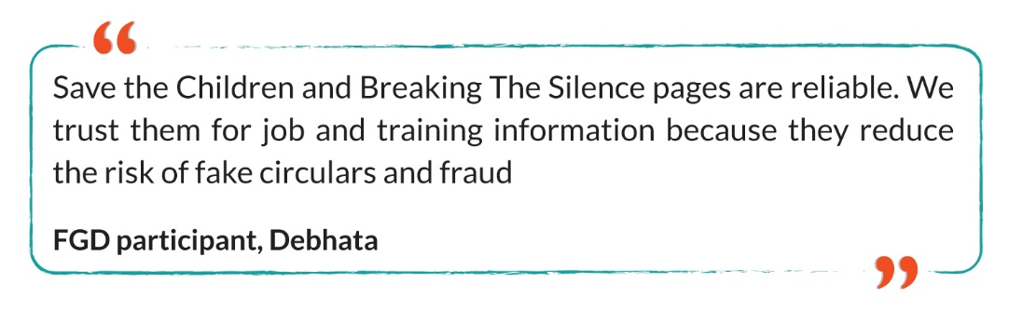
Across all three upazilas, Breaking the Silence as SCI's implementing partner is consistently identified by FGD participants as the most trusted source of employment information, representing the highest-potential strategic asset for programme engagement. The most inclusive actors those offering home-based work, PWD accommodation, minority-sensitive practice, and complaint mechanisms are Rishilpi and Uttaran; actors requiring facility upgrades before endorsement include Taskia Garments, Satata Ladies Tailors, and Monayem Computer and Training Centre. Existing partnership and entrepreneurship opportunities include BSCIC trade fairs, DYD and TTC job fairs, Rupantor's internship and development-sector referrals, Progress Organisation's post-training support, and the Satkhira Chamber of Commerce as an entry point to the private sector employer network. The highest-potential actors for immediate strategic engagement classified as NOW across all three upazilas are TTC, DYD, DWA, BSCIC, Rishilpi, and Breaking The Silence in Sadar; Uttaran, Taskia Garments, Noabeki, DYD, DWA, and Breaking The Silence in Debhata; and local tailoring providers, SUS, local livestock providers, and Breaking The Silence in Ashashuni.

Table 5: Ecosystem Actor Profiles (Satkhira Sadar)
Actor | Type | Key Services | Women Friendly Practice | Priority
Rony Plywood Industry | Private employer | Finishing, cleaning, production; on-the-job training; ongoing labour shortage; wage progression | Separate toilets, CCTV, complaint boxes; no childcare | NOW (wage screen)
Rishilpi International Foundation | Social enterprise | Nakshi Kantha, Aari, jute/straw, tailoring; home-based raw-material delivery; PWD inclusion | Separate washrooms, harassment response, home-based support | NOW
TTC Satkhira | Govt training | Garment, dressmaker, computer operator; job placement cell; job fairs; RFL/Walton employer links | Separate toilets, prayer space, complaint box, residential support | NOW
DYD Satkhira Sadar | Govt training + microcredit | Livestock, agriculture, office/computer, vocational; microcredit; job fairs | Separate toilets, low fees, PWD fee waiver | NOW
DWA Satkhira Sadar | Govt empowerment | Tailoring, beauty, computer, livestock, small business; GBV/legal referral; daycare advocacy | GBV/harassment referral; legal and counselling support | NOW
BSCIC Satkhira | Govt SME / industrial | 5% loans, plot allocation (30% women priority), trade fairs, industrial mentoring | Women prioritised; protected industrial area | NOW
Breaking The Silence / SCI IP | Implementing partner | Participant mobilisation, segmentation, family, community engagement; | Works with NEET/vulnerable women; trusted community actor | NOW
BWRDS | NGO / training | Digital marketing, freelancing, handicraft, tailoring, language training; collaborative | Separate washrooms, breastfeeding, prayer, complaint box | NEXT
Progress / Winrock | Development partner | Entrepreneurship, electrical/sewing; survivor-sensitive; non-formal factory linkage | High attention to survivor safety; avoids hazardous jobs | NEXT
Rupantor | Development NGO | Safe/decent work, internships, development-sector jobs | Gender-equity orientation | NEXT
China Bangla | Food manufacturing | Packaging, cleaning, production; seasonal; low wage BDT 5,500-6,000 | Separate washrooms; wage below threshold | NEXT (wage dialogue required)
Unilever | MNC / FMCG | Territory, finance, HR, supply chain; university degree required | Transport, breastfeeding corner, paid maternity leave | LATER

Table 6: Ecosystem Actor Profiles (Ashashuni)
Actor | Type | Key Services | Women Friendly Practice | Priority
Local tailoring shops / Tohomina Ladies Garments | Private / training | Tailor assistant, women-only training, self-employment, apprenticeship; top FGD sector choice | High  women-only setting | NOW
SUS (Satkhira Unnayan Sangstha) | NGO livelihood | Guru-shishya apprenticeship, loans, RAISE/SF projects; trusted community actor | Moderate-High | NOW
Local poultry/livestock providers | Agriculture / informal | Poultry/duck rearing, cattle/goat, vaccination; home-compatible; 80% female participation | High for home-based work | NOW
Breaking The Silence / SCI IP | Implementing partner | Community mobilisation; minority inclusion mandate | Works with NEET/vulnerable; minority inclusion acknowledged | NOW
Youth Development Office | Govt training | 43 courses; loan support; open to partnership; 300-trainee poultry batch | Moderate-High; women-friendly facilities reported | NEXT
Women Affairs Office | Govt social | Tailoring, livestock, loan disbursement; gender mandate; vulnerable women targeting | Moderate | NEXT
Satata Ladies Tailors / BRAC-linked | Training provider | Tailoring, shop attachment; facility gap no women-friendly toilet | Moderate  (facility needs upgrade) | NEXT (safeguarding check)
Monayem Computer & Training Centre | ICT training | MS Office, graphics, freelancing; lacks dedicated toilet | Weak-Moderate | NEXT (SSC+ only; facility upgrade)
Ashashuni ICT Office | Govt ICT | Freelancing, office applications; prior Her Power project | Currently weak for women | NEXT (facility fix first)

Table 7: Ecosystem Actor Profiles (Debhata)
Actor | Type | Key Services | Women Friendly Practice | Priority
Uttaran Shimanta Technical Institute | Training provider | Fashion garments, mobile servicing; job counselling; job fairs; 6-month follow-up; job replacement; residential support | Residential support, transport allowance, separate toilets, complaint box, PWD inclusion | NOW benchmark model
Taskia Garments | Local employer | Tailoring, block-batik apprenticeship; women-only; seasonal demand | Women-only; no dedicated toilet at site facility upgrade required | NOW (facility upgrade first)
Noabeki Gonomukhi Foundation | NGO | Tailoring, beautician, block-batik, loans, livelihood linkage; 794 trained, 750 reported employed (verify independently) | High female focus; works with vulnerable women | NOW (verify placement data)
DYD Debhata | Govt training | Fish culture, cattle/goat, poultry, tailoring, Nakshi Kantha; microcredit; home-based livelihoods | Home-based work seen as safer; limited disability facilities | NOW / NEXT
DWA Debhata | Govt empowerment | IGA training; beneficiary referral; family/community engagement; programme may restart | Works with vulnerable women; government legitimacy | NOW / NEXT
Breaking The Silence / SCI IP | Implementing partner | Community mobilisation; upazila-specific mapping; | Targets NEET/vulnerable women; disability and religious barriers acknowledged | NOW
Echamoti Technical College | Training provider | Food processing, fish culture, digital/business; NGO links (Sushilan, Uttaran); age 14–18 overlap caution | Gender-sensitive; disability inclusion; WhatsApp complaint group | NEXT (18+ only)
Debhata ICT Office | Govt ICT | Digital literacy support; no current Debhata women’s training project | Temporary building; lacks women/disability-friendly facilities | NEXT (facility fix first)
Satkhira Chamber of Commerce | Private sector | Employer network; sector demand intelligence; potential employer events | N/A | NEXT

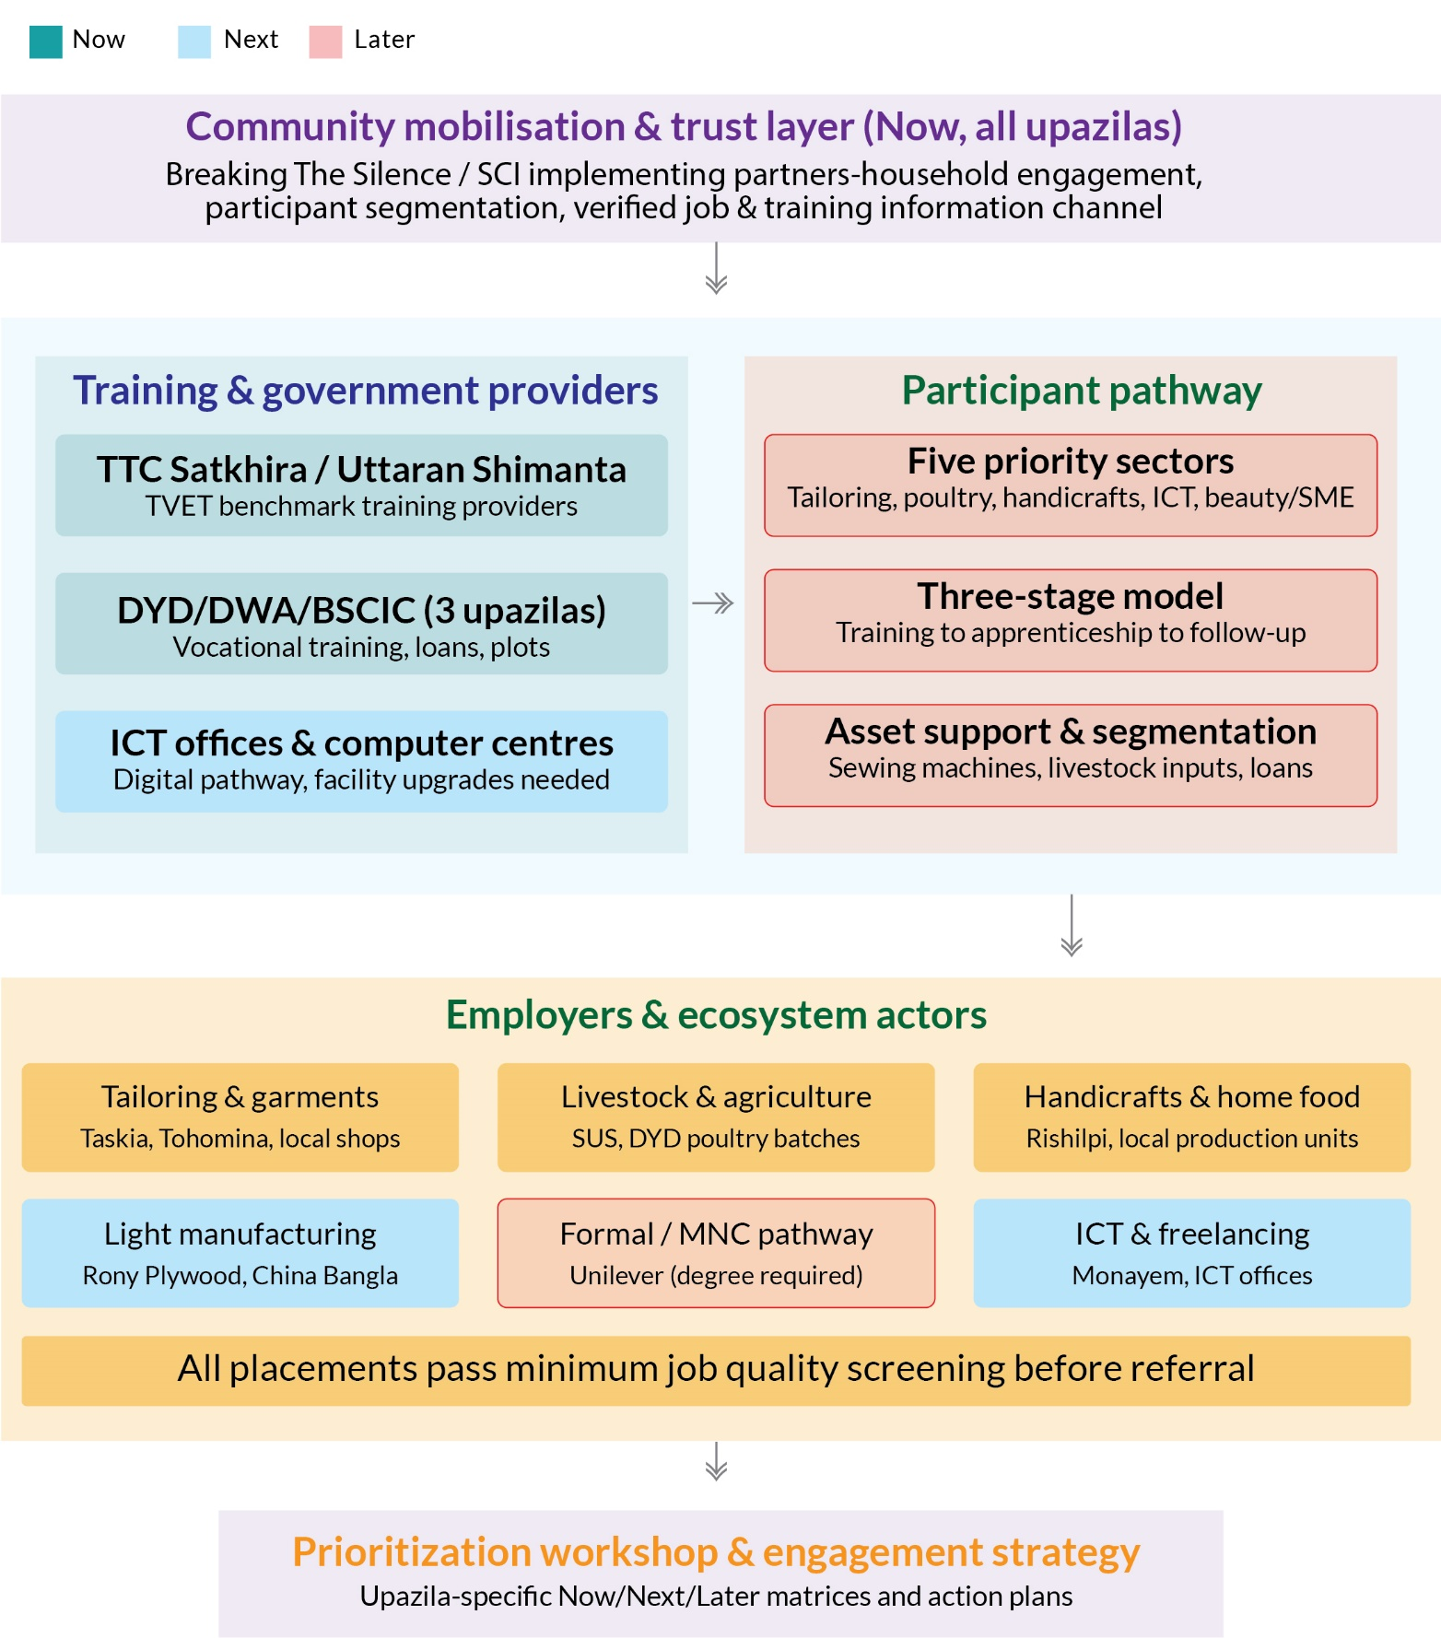

Figure 7: Youth Employment Ecosystem Mapping

